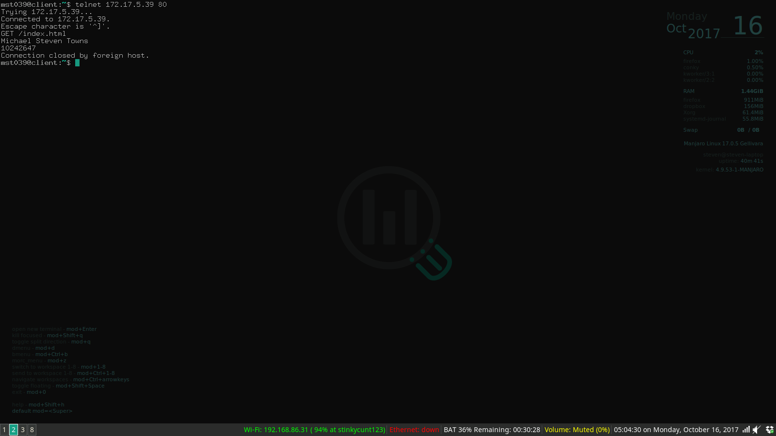

This is the GET /index.html command

It returns the text of index.html (my name and CWID)

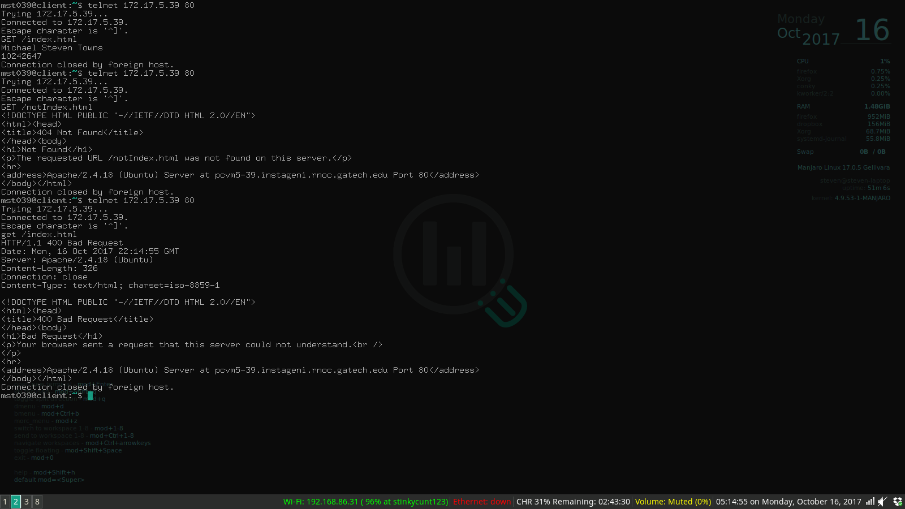

This is 2 other commands

GET /notIndex.html which returns a 404 not found error

get /index.html which returns 400 bad Request

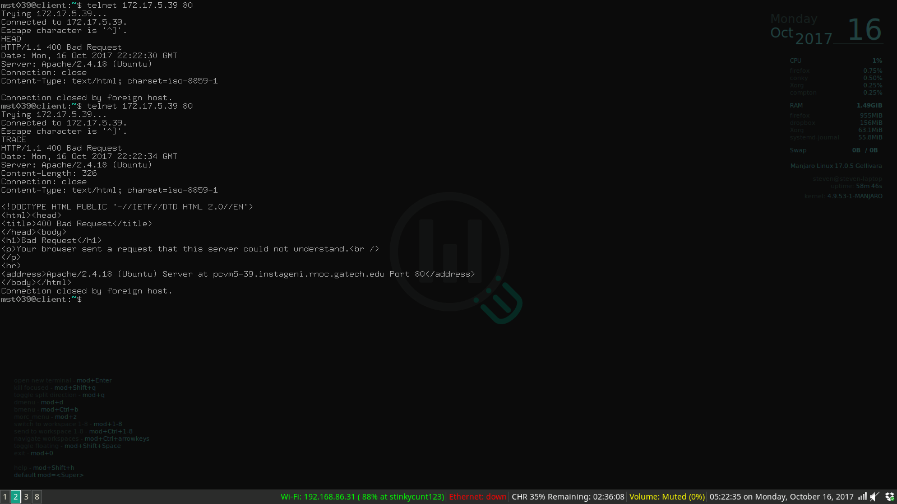

Here are 2 more commands HEAD and TRACE that both return 400 bad request, however HEAD does not return an HTML document.